Assembly Options
Over the past couple of years we have spent time either preparing an assembly based on the Parsha of the week or on teaching the children a variety of songs. Below are links and examples of two Youtube sites that I have found most useful. There are many more resources available to choose from if you wish to do your own searching online, there is plenty of great stuff available.
In order to download and save the Youtube video onto a memory stick you might need to use the following link … This has instructions http://www.clipconverter.cc/

G-d Cast – Short video clips for the Parsha of the week
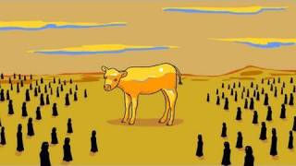

Parshat Ki Tisa: Seeing the Golden Calf
You've gotta SEE it to believe it - the Israelites are out in the desert, and apparently have nothing better to do than melt down all their jewelry to build a golden calf.
https://www.youtube.com/user/gdashdcast/videos?flow=list&view=0&sort=p

Prayer-oeke – Short video clips to teach various Shabbat & Festival Prayers
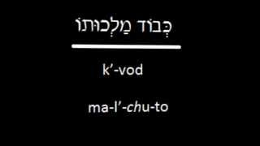
https://www.youtube.com/user/TheUTubeRabbi/videos
https://www.youtube.com/user/TheUTubeRabbi/videos?live_view=500&flow=list&sort=dd&view=0

