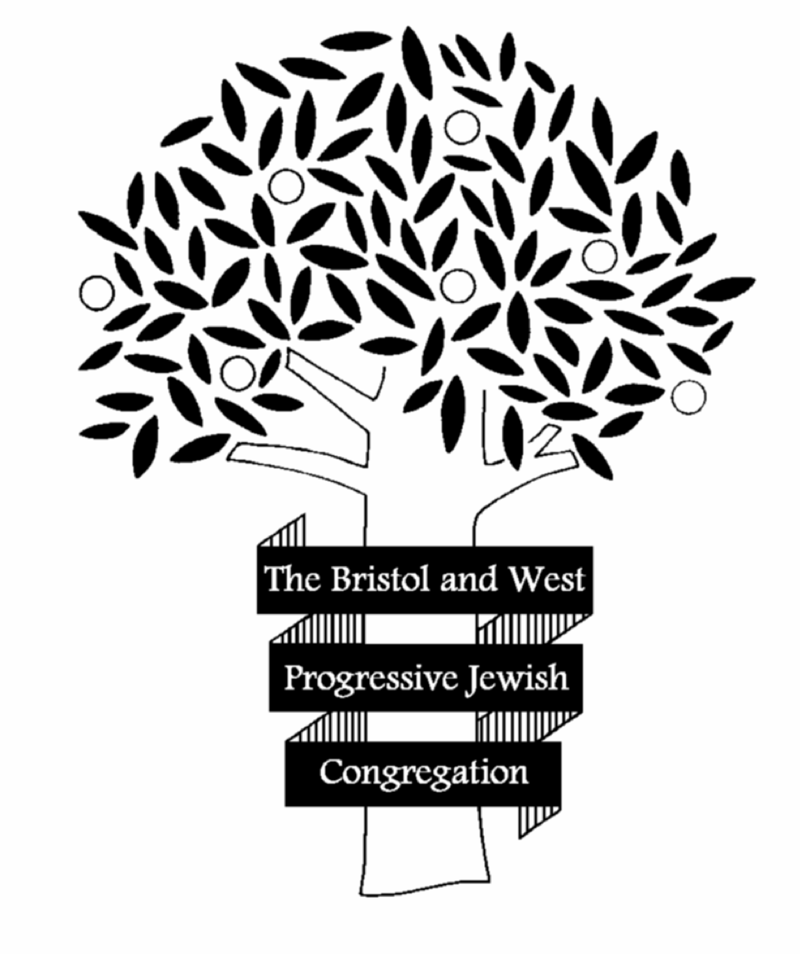
Visit Request
Bristol & West Progressive Jewish Congregation
43-47 Bannerman Road
Bristol BS5 0RR

Name of School/Group ……………………………………………………………………………
Address ……………………………………………………………………………………………………
Teacher/Group Leader Contact ……………………………………………………………….
Teacher’s/Leader’s Position ...………………………………………………………………….
Telephone Number of School/Organisation.…………………………………………….
Email of School/Organisation.………………………………………………………………….
Mobile Contact for Group Leader ……………………………………………………………
Approximate Number of Pupils/Group.……………………………………………………
Year Group/Age Range ……………………………………………………………………………
Particular reason for visit, if any ………………………………………………………………
What, if any prior knowledge do the Pupils/Group have of Judaism?
….……………………………………………………………………………………………………………..
Please list any specific topics you wish to be covered: ………………………………
Please select:
……. Visit to the Synagogue
……. Session at School or other venue
……. Virtual Session

-We ask for a donation of £30 - £50 for visits/sessions, which will go toward the upkeep of the synagogue.
-Please return this form by email to visits@bwpjc.org. Thank you.

